Scraper UI Documentation

**Event Name**: Can be any characters with no restrictions.

**Check**: Searches the database for events with similar names as *Event Name* and populates the drop-down menu next to it.

**--New Event--**: Drop down menu of events in database after clicking the check button. Select --New Event-- for using the name entered in *Event Name* as a new event input.

**Latitude**: restricted to values between -90 and 90.

**Longitude**: Restricted to values between -180 and 180.

**Radius**: restricted to positive integers.

**Keywords**: Any characters are allowed. Different keywords need to be separated by commas. Keywords that are separated only by a space will be searched together.

**Start Date/End Date**: A calendar GUI will pop up when selecting either Start or End date upon selecting a date in the GUI you must click the set button between each date set to set the date for either the start or end date.

**Start time/End time**: Select a time in the drop-down menu on a 24-hour scale started at 00:00.

**Run Standard Scrape**: Runs the standard Twitter scrape over the past 7 days.

**Run Premium Scrape**: Runs the premium Twitter scrape over the past 30-days.

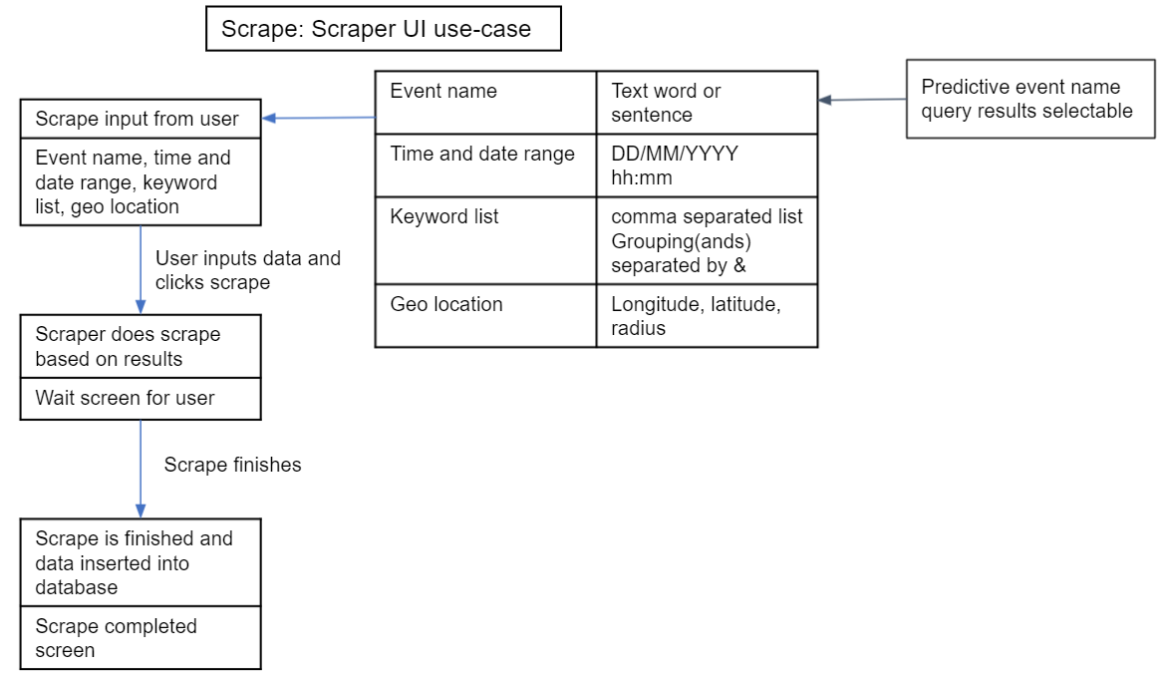

Database UI Documentation

**Database Search**: Window to find events matching to the keywords given and output the lists of posts in the *Post Display.*

**Keywords**: Can be any characters, but are used to attempt to match inputs in the database.

**Check**: Searches the database for events with similar names as *Keywords* and populates the drop-down menu next to it.

**--Choose Event--**: Drop down menu of events in database after clicking the check button. Must select an active event to then use *Run Search*.

**Run Search**: Collects all posts from the event chosen in *--Choose Event--* and creates a new menu to display the posts.

**Post Display**: The window used to display posts in a searchable list using recursive refinement with keyword matching.

**Refining Keywords**: Can be any characters, space separated, finds matching posts that match one or all keywords in their description once *Refine Posts* is used.

**Refine Posts**: Clears out posts that do not match the *Refining Keywords* from the display, in order to reset the post display to the original set, the *Database Search* will need to be run again.